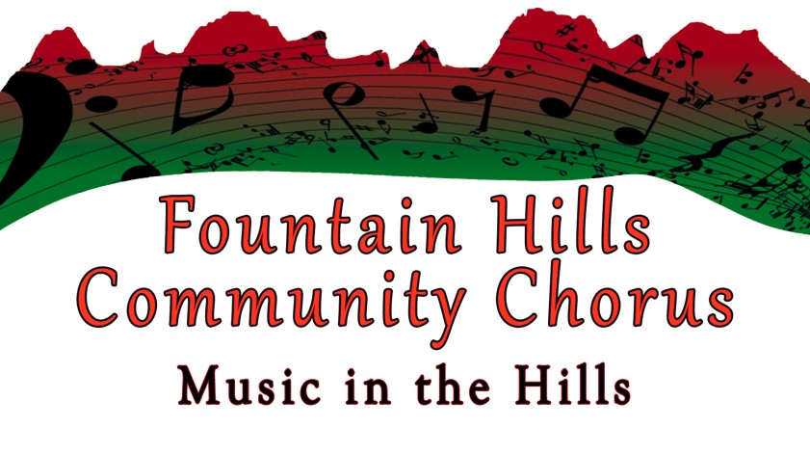
FOUNTAIN HILLS COMMUNITY CHORUS
SCHEDULE – FALL 2026

***All functions are at the Fountain Hills Community Center unless otherwise indicated in red. Monday weekly rehearsals are in the Pima & Hopi Rooms
Rehearsals Mondays, 5:30-7:30 pm
September 14th , 21st, 28th
October 5th, 12th,19th, 26th
November 2nd, 9th (Location may be changed due to voting on the 10th) 16th, 23rd, 30th

Sectionals
Saturday, October 10th, 2026
Tenors & Bases 8:30-10 am
Sopranos & Altos 10-11:30 am

Fall Concert Information
Saturday, December 5th, 4-6 pm Stage Rehearsal
Sunday, December 6th, 1st Holiday Concert - 3 pm Warm Up - 4 pm Performance
Monday, December 7th, 2nd Holiday Concert - 6:30 pm Warm Up - 7 pm Performance

SAVE THE DATES: Spring 2027 Session
First Rehearsal and Registration: January 4th, 2027
Concerts: Saturday, April 3rd and Sunday, April 4th – both at 4pm



