FOUNTAIN HILLS COMMUNITY CHORUS
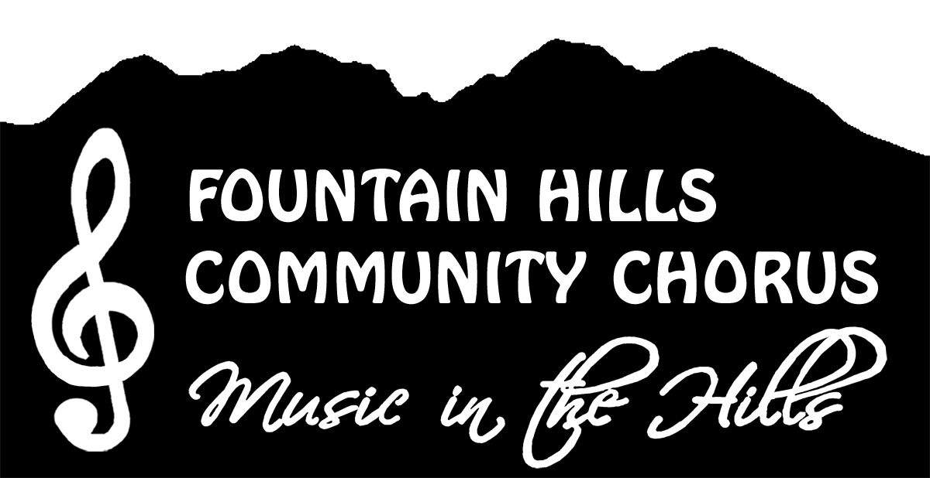
REGISTRATION – SUMMER 2024

CONTACT INFORMATION:
Last Name: First Name:
Nickname:

Street Address: Unit:
City: State: ZIP:

Preferred Phone: Alternate Phone:
Email Address:

EMERGENCY CONTACT INFORMATION:
Contact Name: Relationship:
Preferred Phone: Alternate Phone:

CHORUS PART (circle): Soprano Alto Tenor Bass

MEMBERSHIP DUES:
Current Program Dues**: __________ **$15 for 1 to 3 sessions or $25 for 4 to 6 sessions
NOTE: Please make your check payable to “FHCCA” or to “Fountain Hills Cultural and Civic Association.”*
Or pay with exact change. Dues are not refundable after the Chorus’ third rehearsal.
Cash Check #: _______
The Fountain Hills Cultural and Civic Association is a tax-exempt Section 501(c)(3) organization

PARTICIPATION WAIVER:
I understand that medical insurance is not provided for by the Town of Fountain Hills and Fountain Hills Cultural and Civic Association (FHCCA), and I agree to assume the risk for any injury or illness related to my participation. I agree to make no claims against the Town of Fountain Hills and the Fountain Hills Cultural and Civic Association or any of its officers, employees, or volunteers for any injury or incident arising from this activity, however caused, including liability for negligence. I am physically able to participate in this activity. I realize that neither the Town of Fountain Hills nor the Fountain Hills Cultural and Civic Association is responsible for lost or stolen articles. I understand and agree that I may be photographed as a member of the Chorus and such photos are sometimes used for publicity purposes.

SIGNATURE OF PARTICIPANT: DATE

.

Date received: _____/_____/2024 Initials: _______

