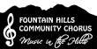 The Fountain Hills Community Chorus
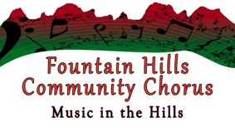
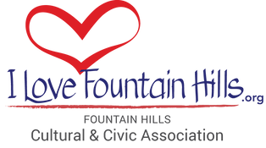
New Member Information

About the Chorus: The Fountain Hills Community Chorus, comprised of approximately 65-100 men and women who sing in four-part harmony, was founded in 1991 by a group of Fountain Hills residents. The chorus is funded entirely from membership dues, concert ticket sales, grants, and donations and is part of the Fountain Hills Cultural and Civic Association (FHCCA), a local nonprofit organization.

Sessions: The Fall Session is from September through early December, and the Spring Session is from January through late May or early April. Members are encouraged, but not required, to participate in both sessions.

Rehearsals: Weekly rehearsals are every Monday night from 5:30 to 7:30 p.m. at the Fountain Hills Community Center, 13001 N. La Montana Drive. Additionally, there is also one section rehearsal and one stage rehearsal scheduled as well. See the Chorus Schedule for dates and alternate locations when the Community Center is closed for holidays.

Concerts: The chorus presents holiday concerts in early December and spring concerts in late March or early April. See the Chorus Schedule for dates and times.

Additional performances: The chorus and small ensembles from the group also perform at community functions from time to time. Additional performances will be announced at rehearsals. All members are encouraged, but not required, to sing at additional performances as their personal schedules permit. Sign-up sheets will be on a table outside our rehearsal room.

Dues: All that is required to join the chorus is completion of a registration form and payment of the session’s dues, currently $50. Dues help cover expenses such as music, performance space rental, and salaries of our director, assistant director, and accompanist. There are no formal auditions, but musical experience is desired.

Attendance: Rehearsal absences are counted from, and include, the session’s first rehearsal. The director, with the board, must approve more than three absences during a session.

Fountain Hills Chamber Singers: The Chamber Singers is an auditioned small group of singers from within the chorus that performs additional SATB music at our concerts. The group rehearses for one-half hour after the chorus’ regular rehearsals. The auditions are usually after the 2nd & 3rd rehearsal singing excerpts from a song sung during that rehearsal.

Name Badges and Member Directories: Each chorus member receives a name badge to wear during rehearsals and a directory which includes members’ contact information. Directories are made available only to chorus members; directory contact information may be used only for chorus-related activities.

Emergency Information: There have been rare instances when chorus members have needed emergency medical attention. Chorus members are strongly urged to put a contact on the registration form to call in case of an emergency. This information is seen only by the Board of Directors

Board Meetings: The Chorus is guided by Board of Directors, all volunteers from the Chorus, and meets monthly. All chorus members are welcome to attend board meetings. The Annual Board Meeting meets in March, during one of our Rehearsals, with includes member elections & addressing any questions or concerns.

Volunteer! The chorus encourages and needs assistance from all chorus members to help with a variety of tasks. The Board consists of 8 voting members, the Director & Assistant Director, and can included 2 Members-at-Large. Contact the Board of Directors chairperson. Contact info for all Board Members are on the Chorus Website https:/fhcc-az.org.

